www.ICUIL.org

ICUIL Board

Chair
Toshiki Tajima

Co-Chairs
Chris Barty

Wolfgang Sandner

Secretary
Terry Kessler

Treasurer
Tsuneyuki Ozaki

Annual Report to IUPAP
2011

International Ultra-high Intensity Laser Initiatives:

- Promoting worldwide high-intensity laser infrastructure
approaching the exawatt power level
- Motivating a path beyond laser-matter interaction in the relativistic
regime toward ultra-relativistic exploration
- Actively collaborating on future laser systems to support potential
applications in accelerator science

The International Committee on Ultra-High Intensity Lasers (ICUIL) is actively concerned with the growth and vitality of the whole international field of ultra-high intensity laser (HIL) science, technology and education. During 2011, the HIL community made great progress in areas of science and technology and collaborated in the study of laser acceleration involving future laser sources and concomitant laser acceleration science and technology. As highlighted below, members of ICUIL have been very active in promoting the strong collaborations needed to design and build advanced laser infrastructure such as the facility planning required for lasers approaching the exawatt power level. Our primary goal continues to be promoting unity and coherence in the field by convening conferences dedicated to ultra-high intensity lasers and their applications. The 2012 ICUIL Conference in Szeged, Rumania promises to be another excellent forum for exchange between scientists and engineers in this dynamic field.

ICUIL Related Science and Technology Highlights

- ICUIL and ICFA have exercised their Joint Task Force (JTF) on Future Applications of Laser Acceleration to promote and encourage international collaboration between the accelerator and laser communities. Collaborative planning on long-range research such as laser driver development, suggested by CERN scientists, was initiated. The second Joint ICUIL/ICFA Workshop on High Power Laser Technology for Future Accelerators was held at LBNL, United States from September 20-22, 2011. The JTF continued to outline a roadmap for advancing laser technology to meet the challenge of future accelerators that use or rely on very high- average power lasers and that are beyond state-of-the-art. As was the case for the first workshop, the purpose of gathering this select group of researchers was to provide a forum where accelerator and laser science and technology was discussed in support of the great challenges that lay ahead in developing future technology for photon and particle based tools. The JTF made headway towards the development of high average power lasers for future accelerators. Both, the ICUIL and ICFA organizations, are working groups within IUPAP.

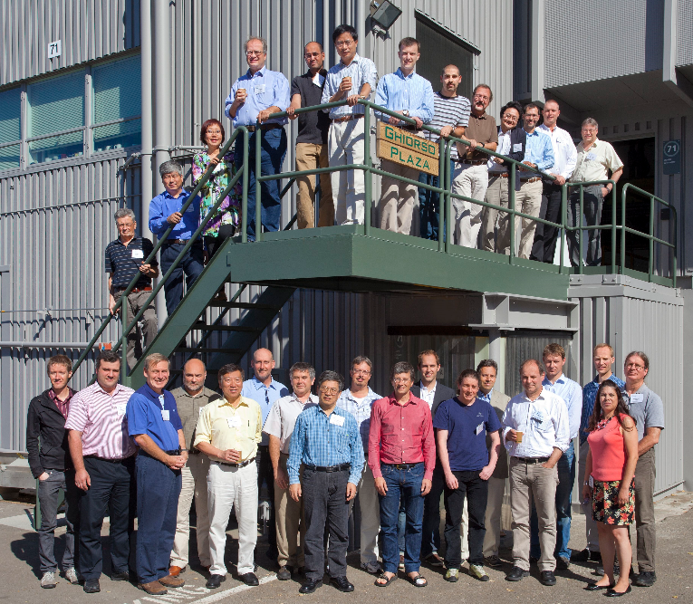

JTF Workshop – September 2011

- The European Network for Novel Accelerators (EuroNNAc) was formed this year and gathered its first workshop in CERN on May 3-6 to explore possibilities for applying ultra-high gradient acceleration techniques in large electron beam facilities. It is preparing a coherent European strategy, maximizing synergy and maintaining productive competition. The need for one or several European beam test facilities is being reviewed. By 2013, the network should agree on possibilities for a substantial proposals for the next Framework Programme (FP8). EuroNNAc has been formed by CERN, DESY (German Electron Synchrotron), and Ecole Polytechnique in France and is part of EuCARD, the EU co-funded European Coordination for Accelerator R&D. EuCARD is a common venture of 37 European Accelerator Laboratories, Institutes, Universities, and Industrial Partners. T. Tajima, the ICUIL Chairmn, is a representative in the EuroNNAc Committee from ICUIL.

- LASERLAB-EUROPE is in the second phase of its successful cooperation between many countries. This Consortium has grown much larger, involving 26 Laser Research Infrastructures from 16 European member states. They gained new partners including Spain, Portugal, Poland, Slovakia, Romania, Hungary and Latvia as well as associate partners including Bulgaria, Austria and Denmark. 20 facilities offer access to their labs for European research teams. Given the importance of lasers and their applications in all areas of sciences, life sciences and technologies, the main objectives of the consortium are to form a competitive, inter-disciplinary network of European national laser laboratories, to strengthen the European leading role in laser research through Joint Research Activities, to engage in the Transnational Access Program in a co-ordinated fashion for the benefit of the European research community, providing about 1100 days of access per year for European researchers, to increase the European basis in laser research and applications by reaching out to neighboring scientific communities and by assisting the development of Laser Research Infrastructures on both the national and the European level. A Laserlab-Europe workshop was held on September 13-14, 2011 in Bordeaux, France jointly by the IFSA 2011 local organizing committee and the Central Laser Facility, UK, to investigate techniques to generate high contrast laser pulses and to characterize them, as well as to explore scientific fields that could then be explored.

- One of the highest profile, ultra-high intensity, international laser projects is the 850M euro European Extreme Light Infrastructure (ELI). ELI consists of three pillars in three countries each with separate high intensity laser themes. In the Czech Republic. ELI-Beamlines facility will provide a variety of petawatt scale laser capabilities of differing pulse duration and repetition rates. These systems will enable creation of secondary, laser driven particle and light sources for basic science and industrial applications. In the Romanian ELI-Nuclear Physics facility, two 10 PW lasers are planned to be constructed in conjunction with a world-leading gamma-ray source to investigate a wide range of nuclear science. In Hungary, the ELI-ALPS facility will concentrate on the development and applications of intense sources of attosecond laser pulses. Each of the ELI projects are to be funded from developmental funds from the EU. This process requires a series of approvals first in the individual countries and then by Brussels. In April of this year, the Czech Republic became the first ELI pillar to receive formal approval from Brussels to proceed. The Romanian effort has completed a number of workshops and a formal package will be submitted for approval to Brussels. The Hungarian effort will follow. When complete, these three state-of-the-art laser facilities will become showcase venues for the advancement of ultrahigh intensity science and related applied technology. The ICUIL ex-chair, G. Mourou, and the current ICUIL chair and chair of the Science Advisory Committee, T. Tajima, have played an essential role in persuading the EU to support this project.

- The International Center for Zetta-Exawatt Science and Technology (IZEST) was launched by the approval and funding from the French Ministry of Research in September, 2011. An international team of scientists and institutions is being formed to promote laser-driven high energy and fundamental physics within the Euro-NNAc initiative. The immediate objective of IZEST will be to design and construct the first large scale exawatt-based facility, in collaboration wth the XCELS in Russia and the 4th Pillar in the EU, to create colliding high energy particle beams which provide extremely high gradients to enable compact accelerators. It will provide high energy particles to enable the search of low mass particles for dark energy and dark matter. This facility will also be capable of accelerating ions to multi-TeV and laser-driven ion bunches inducing wakefields for multi-TeV electron acceleration. The facility will be constructed around the (10-100KJ) LIL laser at CEA of France with 10-100kJ. IZEST will facilitate XCELS by training students and personnel at all levels. It is aimed at creating new technology and carrying out aggressive technology transfer followed by corporate spin-offs in medical, energy, and industrial applications.

- One of several Russian Mega-Science Projects is to establish a large research infrastructure, the International Center for Extreme Light Studies (XCELS), that includes laser sources with peak power exceeding that of existing sources by two orders of magnitude. The core of the planned infrastructure is a novel source of light with 0.1 - 0.2 exawatt power with potential enhancement to 1 exawatt. Experiments are expected to begin in 2018. Fundamental processes of laser-matter interaction at this power level will create an absolutely new area of knowledge. Also, unique opportunities will provide insight into the space-time structure of vacuum. XCELS will ensure technological breakthrough in a number of medical, energy, and industrial applications. Creation and exploitation of XCELS will be accomplished by collaborative efforts between many Russian research and educational centers. XCELS will be an international research center functioning within the framework of the cooperation agreement between RF and other countries.

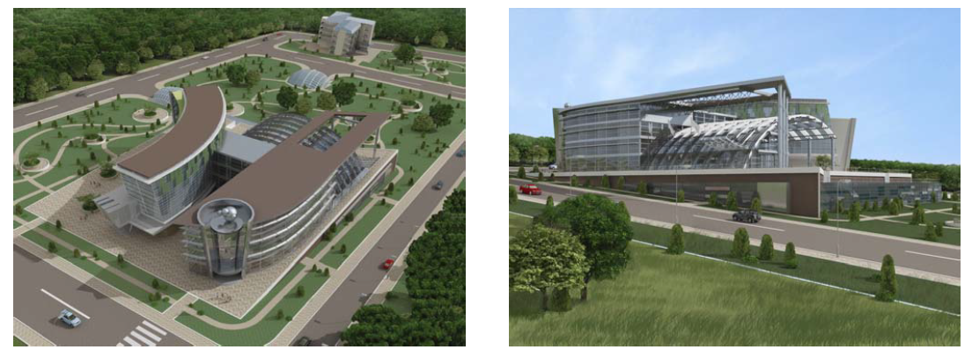
Prospective view of the future XCELS complex

ICUIL Activity Overview

The ICUIL is actively concerned with the growth and vitality of the whole international field of ultra-high intensity laser science, technology and education. Our goals are to provide a venue for discussions, among representatives of high-intensity laser facilities and members of user communities, on international collaborative activities such as the development of the next generation of ultra-high intensity lasers, exploration of new areas of fundamental and applied research, and formation of a global research network for access to advanced facilities by users. In addition to the areas highlighted in this report where ICUIL members have contributed driving support, members have completed the following activities to achieve the above stated goals.

ICUIL Biennial Conferences

The 5th biennial ICUIL Conference will be held from September 26 to October 1 in Szeged, Rumania. This conference will be hosted by the National Institute for Laser, Plasma and Radiation Physics, Bucharest, with D. Dumitras serving as the General Chairman. Following the success of the 2004 (Lake Tahoe, USA), 2006 (Cassis, France), 2008 (Tongli, China), 2010 (Watkins Glen, USA) conferences, the 2012 conference promises to be another excellent opportunity for ICUIL to promote unity and coherence in the field of ultrahigh intensity lasers and their applications.

2011 Annual General Assembly (GA) Meeting

A nine member quorum is anticipated for the annual GA meeting held on the last day of the 2011 LEI Conference in Hungary. The agenda for the three-hour meeting will consist of member rotation, the 2012 ICUIL Conference, website development, the world map, fund raising, the annual newsletter, laser infrastructure initiatives, and the ICUIL/ICFA joint task force. Bi-monthly teleconferences continue to be effective in keeping each of these activities alive despite the purely volunteer nature of the ICUIL group.

ICUIL Member Rotation

Member rotation has been carried out, in small steps, to maintain continuity and ensure that ICUIL continues to advance while maintaining balance between the various high field science sections of IUPAP. Three of the seventeen-member ICUIL were replaced 2010 and several members will either be replaced or renewed for four years on a case by case basis in 2012. Candidates from regions of the globe where expansion of high-intensity laser infrastructure is increasing are highly encouraged to join ICUIL.

ICUIL Newsletter

The second ICUIL Newsletter was sent out to the high intensity laser (HIL) community on April 2011. The chief editor, C. Labaune, managed the illustration and publication resources to distribute an eight-page newsletter to hundreds of readers, highlighting the major laser construction and laser science projects within the HIL community, major conferences, and related workshops. ICUIL’s goal is to continue publishing an annual newsletter.

Fund raising

ICUIL has continued to work towards expanding its corporate support program to afford maintenance of the ICUIL website, publish an annual newsletter and support biennial conferences. To secure corporate support during the non-conference year, the Treasurer has shared the odd/even year support allocation plan with participating vendors worldwide (shown below) In addition, excess organizational support from the 2010 ICUIL Conference was allocated towards website and newsletter expenses.

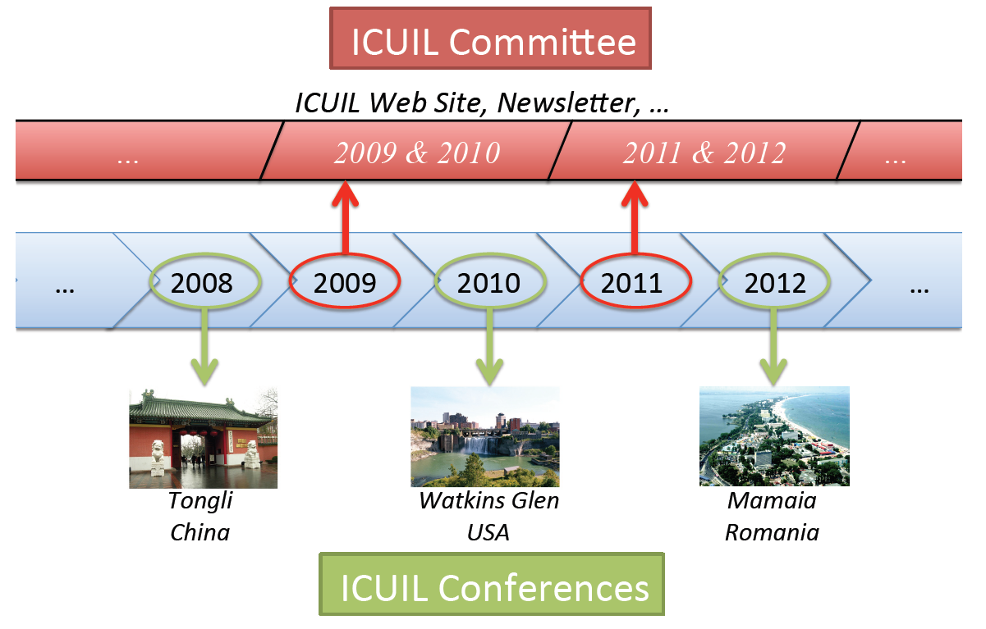

ICUIL Website

The ICUIL website is now managed in India by Image Online Pvt. Ltd.. The professional website manager is in close contact with the ICUIL chairman, secretary, and members involved in improving web presence. One of the features of the ICUIL website is an interactive world map which highlights the high intensity laser facilities around the world as shown below. By comparison to the first world map made in 2008, it is evident that the number of laser facilities has grown tremendously.

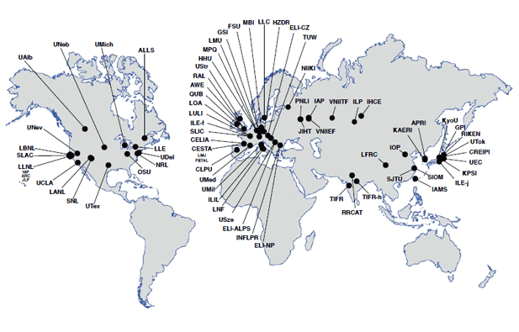

2011 World Map of High-Intensity Laser Facilities

