www.ICUIL.org

ICUIL Board

Chair
Toshiki Tajima

Co-Chairs
Chris Barty

Alexander Sergeev

Secretary
Terry Kessler

Treasurer
Tsuneyuki Ozaki

Annual Report to IUPAP
2012

International Ultra-high Intensity Laser Initiatives:

- Promoting worldwide high-intensity laser infrastructure
approaching the exawatt power level
- Participating in the journey beyond laser-matter interaction in the relativistic
regime toward ultra-relativistic exploration
- Defining the specifications for future laser systems to support potential
applications in accelerator science

The International Committee on Ultra-High Intensity Lasers (ICUIL) is actively engaged with the growth and vitality of the whole international field of ultra-high intensity laser (HIL) science, technology and education. During 2012, the HIL community made great progress in areas of science and technology and collaborated in the study of laser acceleration involving future laser sources and concomitant laser acceleration science and technology. As highlighted below, members of ICUIL have been very active in promoting the strong collaborations needed to design and build advanced laser infrastructure such as the facility planning required for lasers approaching the exawatt power level. Our primary goal continues to be promoting unity and coherence in the field by convening conferences dedicated to ultra-high intensity lasers and their applications. The 2012 ICUIL Conference in Mamaia, Rumania provided another excellent forum for exchange between scientists and engineers in this dynamic field.

ICUIL Related Science and Technology Highlights

- The European Extreme Light Infrastructure (ELI), the world's first international laser infrastructure project, had made substantial progress towards implementation. ELI is part of the European Union's ESFRI Roadmap for large-scale Pan-European infrastructures. It is designed as a distributed user facility, presently consisting of three pillars in the Czech Republic, Hungary, and Romania, respectively. They pursue complementary objectives under a joint scientific mission, with a total planned investment volume of about 850 M€. A fourth pillar, aiming at applications with highest laser powers (of the order of 100 Petawatts) and highest intensities, shall complete ELI's scientific goals. Its location and funding will be decided in the near future.

ELI is one of the highest profile, ultra-high intensity laser projects within the ICUIL community. In the Czech Republic, ELI-Beamlines facility will provide a variety of petawatt scale laser capabilities of differing pulse duration and repetition rates. These systems will enable creation of secondary, laser-driven particle and light sources for basic science and industrial applications. In the Romanian ELI-Nuclear Physics facility, two 10 PW lasers are planned to be constructed in conjunction with a world-leading gamma-ray source to investigate a wide range of nuclear science. In Hungary, the ELI-ALPS facility will concentrate on the development and applications of intense sources of attosecond laser pulses.

ELI is the first ESFRI Infrastructure to employ an innovative funding model for construction, namely the use of EU Structural Funds. While being financial tools to implement the Regional policy of the European Union (and making up one of the largest items of the Union’s budget) these funds contain a fraction which is ear-marked for research. Using it for construction of Pan-European research infrastructures is presently novel, but supposed to become standard in future EU Programs, such as HORIZON2020 starting in 2015. Two of the ELI pillars, ELI-Beamlines in the Czech Republic and ELI-NP in Romania, have by now (end of 2012) received final approval for use of Structural Funds for constructing their facilities. The application for ELI-ALPS in Hungary is under way.

In the Fall of 2012 ELI will have created a new legal entity, the ELI-DC Association, in order to manage and support the implementation of the existing and future ELI research centers and to preserve the pan-European dimension of the overall project. In particular, this Association will ensure consistency and complementarity between the respective main scientific missions of the pillars, and initiate and coordinate the process leading to the establishment of the pan-European consortium in charge of the future operation of ELI – a European Research Infrastructure Consortium (ELI-ERIC). ICUIL member Wolfgang Sandner (Board member until 9/2012) is its designated Director General. ICUIL and ELI are determined to preserve and continue their close collaboration to the benefit of the international ultra-high intensity laser community.

- LASERLAB-EUROPE is the European Consortium of major Laser Research Infrastructures. In a rapidly changing environment of laser science the project defines its position between the basis of university groups and users on the one hand, and the Pan-European facilities on the other, keeping very close ties with both. Geographically, LASERLAB-EUROPE covers the majority of European member states, following recent efforts to include partners from all over Europe 27. Scientifically, it covers many areas of laser science and applications with particular emphasis on short-pulses and high-intensities.

Recently this field has experienced remarkable advances and breakthroughs in laser technologies and beam parameters. Novel applications range from coherent x-ray generation, laser particle acceleration, laboratory astrophysics, and attosecond physics to fusion research, materials research, and biomedicine, to name only a few. Consequently – and also as a sign of its exceptional internal coherence - the European laser community has engaged in the world's first truly international laser infrastructures, ELI and HiPER. Besides offering unprecedented research opportunities, these infrastructures, together with the LASERLAB-EUROPE Consortium, will substantially contribute to innovation and help addressing the grand societal challenges.

The overall objectives include:

- Assisting Europe to create new infrastructures in member states where they are still lacking including, but not restricted to, ELI and HiPER. In particular, LASERLAB-EUROPE is convinced that national RIs will remain seminal for creating and sustaining national user communities, and can only be complemented, but not replaced by activities at the European level.

- Increasing the European basis of human resources. This is an immediate and imminent consequence of the above. Measures include networking activities like user training, a new approach on staff mobility and training, coordination of education activities with other projects and with industry, and Access.

- Laying and maintaining the research basis for future areas in laser science and applications. This is a genuine, forward-looking objective for a network located in between the diversified and creative scientific user basis and the mission-oriented Pan-European RIs. It involves re-structuring and expanding the existing Joint Research Activities (JRA) as well as maintaining the breadth of Access opportunities at the highest scientific quality.

LASERLAB-EUROPE was first to develop an integrated concept of Transnational Access under Consortium governance, employing an external selection panel to ensure ultimate scientific quality. The concept includes “Dynamic Access”, i.e. flexible re-distribution of EC resources according to varying offers and/or demand. Under this scheme the Consortium will provide nearly 1000 days of Access per year to European users through research opportunities at 20 RIs from 11 countries. In its Joint Research Activities LASERLAB-EUROPE will react to new scientific developments, including those stimulated by ELI and HiPER. A total of four JRAs include innovative radiation sources at the extremes, charged particle acceleration with intense lasers, research on lasers for innovation, technology and energy, and laser and photonics for biology and health.

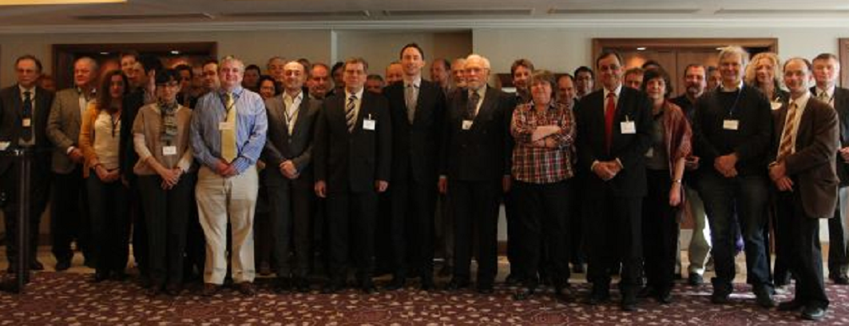

ICUIL member, Wolfgang Sandner (first row, fourth from the left), has led the LASERLAB-EUROPE effort for more a decade and is currently Director General of ELI.
- ICUIL and ICFA have exercised their Joint Task Force (JTF) on future applications of laser acceleration to promote and encourage international collaboration between the accelerator and laser communities. The JTF continued to outline a roadmap for advancing laser technology to meet the challenge of future accelerators that use or rely on very high-average power lasers and that are beyond state-of-the-art. At the last IPAC2012 meeting in New Orleans a meeting was held with the ICFA Advanced and Novel Accelerator Panel. At that meeting Wim Leemans, an active ICUIL member, proposed to hold a third joint workshop on high intensity photon particle interactions (HIPPI). In May, 2012 a workshop was held at LBNL upon the request of DOE-HEP to look at what we can learn from doing photon-particle beam studies that is not well known or understood. The outcome of that workshop was extremely positive with several new experiments being identified at facilities that are becoming available (BELLA, PW at 1 Hz, and the ELI facilities). It would not be a "snapping the vacuum" type of experiment but rather build on the E-144 experiments at SLAC from the mid-nineties where the SLAC beam collided with a TW laser pulse by using laser plasma accelerated beams and ultra-high peak power lasers, i.e. inverse Compton scattering. The proposal resonated with the ICFA-ANA panel and was presented at the ICFA meeting. Mitsuru Uesaka’s presentation included: "Dr.Wim Leemans, chair of the ICFA-ICUIL joint task force committee, proposes that the 3rd ICFA-ICUIL workshop be dedicated to intense laser interaction with high-energy particle beams. This is to reflect new interest and opportunities in nonlinear QED physics studies. This should bring laser/accelerator/detector communities closer. The ICFA-ANA panel strongly endorses this idea and charges Leemans with organizing such a workshop. He reports that thanks to the ICFA-ICUIL joint task force activities development of high-power lasers suitable for advanced accelerator development is now entering the stewardship of US DOE office of science HEP and BES.” Both, the ICUIL and ICFA organizations, are working groups within IUPAP.

- International Zettawatt-Exawatt Science and Technology (IZEST) is based on a laser-based high energy physics paradigm with new societal applications. Fundamental high energy physics has been mainly driven by the high energy fermionic colliding beam paradigm. Today the possibility to amplify lasers to extreme energy and peak power offers, in addition to possibly more compact and cheaper ways to help HEP, a suite of complementary new alternatives underpinned by single shot, large field laser pulses, that together we could call laser-based high field fundamental physics. The main mission of the International IZEST center is to muster the scientific community behind this new concept. As an example, we propose to use the laser field to probe the nonlinearity of vacuum due to nonlineairities and light-mass weak coupling fields such as the Heisenberg-Euler QED, dark matter and dark energy. We envision that seeking the non-collider paradigm without large luminosity will substantially shorten our time-line; we further accelerate the latter by adopting the existing large energy laser LIL. The accelerated research on the non-collider paradigm in TeV and beyond could stimulate innovation in collider concepts such as lower luminosity paths, novel radiation cooling, and gamma-gamma colliders. The advancement of intense short-pulsed laser energy by 2-3 orders of magnitude could provide a tremendous potential of unprecedented discoveries. These include: TeV physics, physics beyond TeV, new light-mass weak-coupling field discovery potential, nonlinear QED and QCD fields, radiation physics in the vicinity of the Schwinger field, and zeptosecond dynamic spectroscopy of vacuum. In addition, we want to take advantage of the ultrashort particle or radiation pulses produced in the femto, atto, and zeptosecond timescale to perform a new type of particle/radiation precision metrology that would help to remove the uncertainty around the neutrino speed. Finally, the TeV particles that can be produced on demand could offer a new tool to TeV astrophysics.

IZEST constitutes what may be the most audacious laser challenge sofar. It will require producing the highest peak power in the Exawatt- Zettawatt range or 10-100 times what is possible today with state-of-the-art technology. It is also part of the IZEST mission to study ways to produce ultra-high peak power pulses at high repetition rate, greater than 1kHz. To reach its bold goals, IZEST demands a complete laser technology overhaul. For instance, by learning to master plasmas, optical components with 10⁴ times higher damage threshold could be conceived, bringing the optical component size down dramatically; square meter optics reduce to one square centimeter. These components could work at very high fluences ~5-10kJ/cm2 instead of the current limit of 1 J/cm2.

IZEST will unify the world laser and high energy community around common goals. Today, a number of exawatt class facilities in Europe and in the world are already in the planning stage, such as the ELI-Fourth Pillar, the Russian Mega Science laser, as well as possible Japanese and Chinese exawatt lasers. IZEST should serve as a common platform opened to the international scientific community with a passion for emerging scientific opportunities and the desire to participate. The IZEST headquarter is located at the Ecole Polytechnique. The experimental program will be performed at the beginning on the most powerful European laser PETAL at the CEA-CESTA in Bordeaux and on the Russian Exawatt once completed. But most of the preparatory activities will be carried out in the IZEST-associated laboratories around the world. Almost 30 laboratories in 13 countries have signed a collaboration agreement with IZEST. The second IZEST meeting on "The Ascent of Laser-based High Energy Physics" will be held from November 13th to 15th at Strathclyde University, Scotland. The meeting will include a presentation from Peter Higgs as a distinguished speaker, and many other prominent speakers. The main objective of the conference will be to explore the potential of very high fields available from the next generation of high power lasers and also the potential of combing them with high energy particle beams from laser-plasma accelerators, for fundamental studies of the structure of matter. The IZEST conference will cover the different aspects of laser-based fundamental physics.

- The Korean national nine-year program, "Ultrashort Quantum Beam Facility Construction Program", will be successfully completed in 2012. This Korean Petawatt system has already started an international users' service. As a following program, the Korean government is now forming a national plan for applied research projects using this facility.

ICUIL Activity Overview

The ICUIL continues to be actively concerned with the growth and vitality of the whole international field of ultra-high intensity laser science, technology and education. Our goals are to provide a venue for discussions, among representatives of high-intensity laser facilities and members of user communities, on international collaborative activities such as the development of the next generation of ultra-high intensity lasers, exploration of new areas of fundamental and applied research, and formation of a global research network for access to advanced facilities by users. In addition to the many highlighted areas where ICUIL members have contributed driving support, members have also completed the following activities to achieve the above stated goals.

ICUIL Biennial Conferences

The 5th biennial ICUIL Conference was held from September 16 to September 21 in Mamaia, Rumania. This conference was hosted by the National Institute for Laser, Plasma and Radiation Physics, Bucharest, with D. Dumitras serving as the General Chairman. More than 170 attendees from around the world participated in an excellent program including 80 talks and 35 posters. Three of the invited talks given by ICUIL members focused on high intensity laser facilities around the word; W. Sandner - European Facilities, C. Barty - American Facilities, and H. Azechi - Asian Facilities. Following the success of the 2004 (Lake Tahoe, USA), 2006 (Cassis, France), 2008 (Tongli, China), 2010 (Watkins Glen, USA) conferences, the 2012 conference was another excellent opportunity for ICUIL to promote unity and coherence in the field of ultrahigh intensity lasers and their applications.

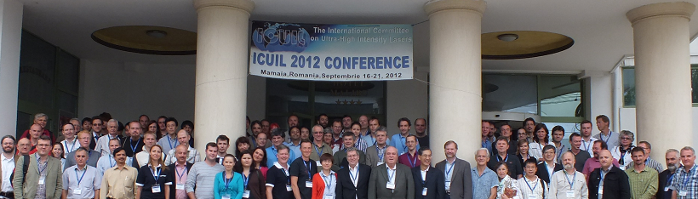

More than170 participants gathered at the 2012 ICUIL Conference in Mamaia, Romania.

A competitive poster session was held at the 2012 ICUIL Conference. Many young scientists from around the world presented their work during the regularly scheduled poster sessions. Four members of the ICUIL Board served as judges of the posters and presentations. First prize was awarded to C. Brabetz of Germany, second prize to L. Ionel of Romania, and third prize to K. Izuno of Japan. The actual posters are shown in Appendix A.

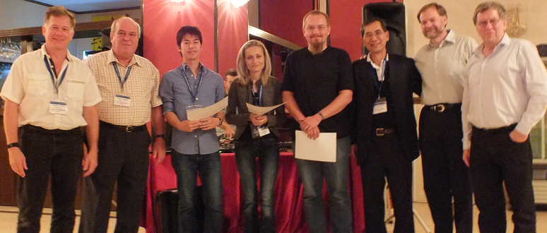

Young scientists (center), poster judges from ICUIL Board, and conference chairman (2nd)

2012 Annual General Assembly (GA) Meeting

A twelve member quorum was reached at the annual GA meeting held on the last day of the 2012 ICUIL Conference in Rumania. The agenda for the three-hour meeting consisted of member rotation, the 2012 and 2014 ICUIL Conferences, website development, the world map, fund raising, and laser infrastructure initiatives and collaborations such as ELI and IZEST. Bi-monthly teleconferences continue to be effective in keeping each of these activities alive despite the purely volunteer nature of the ICUIL group.

ICUIL Member Rotation

Member rotation has been carried out, in small steps, to maintain continuity and ensure that ICUIL continues to advance while maintaining balance both geographically and between the various high field science sections of IUPAP. Many of the 17 member ICUIL team elected to continue for another four-year term. One of the two Co-chairman was replaced, one member terminated his service, while one associate member was voted into full membership. Candidates from regions of the globe where expansion of high-intensity laser infrastructure is increasing are highly encouraged to join ICUIL. In addition, ICUIL will be represented at the PAERIP seminar on Africa-Europe research infrastructures in Trafalgar Square, London on 17 October 2012. This seminar is aimed at promoting science and technology (S&T) partnerships between the European Union (EU) and African Union (AU).

ICUIL Newsletter

The third ICUIL Newsletter (Volume 3) was sent out to the high intensity laser (HIL) community on May 2012 and is also available at the ICUIL website. The chief editor, C. Labaune, managed the illustration and publication resources to distribute an eight-page newsletter to hundreds of readers, highlighting the major laser construction and laser science projects within the HIL community, major conferences, and related workshops. ICUIL’s goal is to continue publishing an annual newsletter.

Fund raising

ICUIL has continued to work towards expanding its corporate support program to afford maintenance of the ICUIL website, publish an annual newsletter and support biennial conferences. To secure corporate support during the non-conference year, the Treasurer has shared the odd/even year support allocation plan with participating vendors worldwide (shown below) In addition, corporate support accumulated from 2008 through 2012 was allocated towards website and newsletter expenses, with remaining funds targeted towards support of new outreach activities.

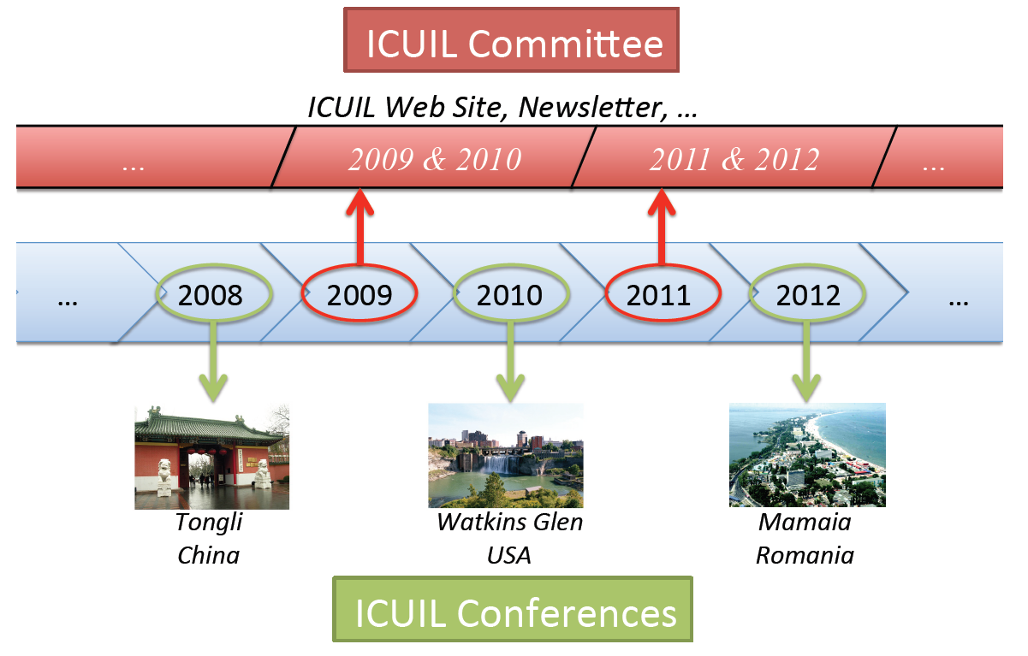

ICUIL Website

One of the features of the ICUIL website is an interactive world map which highlights the high intensity laser facilities around the world as shown below. A survey of the worldwide laser community has been conducted by ICUIL in an effort provide an accurate accounting of all existing and planned ultrahigh intensity laser capabilities. This survey has included input from more than 100 individuals representing every leading laser institution and facility and has gathered more than 300 pages of related materials. From these interactions and materials, a map of all existing and planned facilities that are capable of producing intensities above 10E19 W/cm2 (the present ICUIL definition of “ultrahigh” intensity”) has been created. The map exists on the ICUIL web site both in downloadable, high quality static form and also as a dynamic interactive map based on an underlying google.maps engine that has been licensed by the Lawrence Livermore National Laboratory (LLNL) for this purpose. LLNL has agreed to host and maintain the dynamic map for ICUIL including all the functionality of the underlying google.maps engine and allows users to 1) zoom to the actual facility location both in street view and satellite view 2) see a representative photo of the facility/laser or experiments 3) access a web link to the institution’s web pages and 4) in principle do any other task that might be performed with google maps.
The data base generated in the creation of the ICUIL world map reveals that ICUIL related activities are growing worldwide at an incredible pace. In 2009 the sum of the peak power from all existing “ICUIL” related facilities was ~12 PW. By 2015 the survey data suggests this number will be almost 130 PW. Simple estimates based on the scale of facilities currently being constructed and planned further suggests that more than 1500 new scientists and staff may be required to complete these projects and that the total worldwide ultrahigh intensity laser enterprise over this period will exceed $4.5B. It is the intent of ICUIL to maintain an up to date map via periodic survey mailings to the community and via input obtained from the community at the biennial ICUIL conferences.

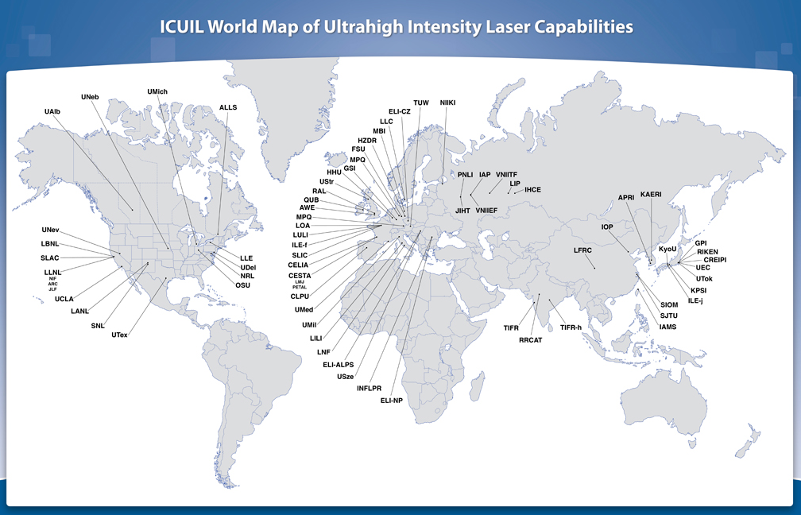

2012 World Map of High-Intensity Laser Facilities
APPENDIX A – Young Scientist Posters – 1st Place

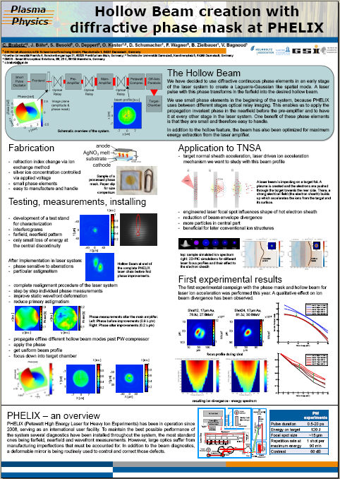
APPENDIX A – Young Scientist Posters – 2nd Place

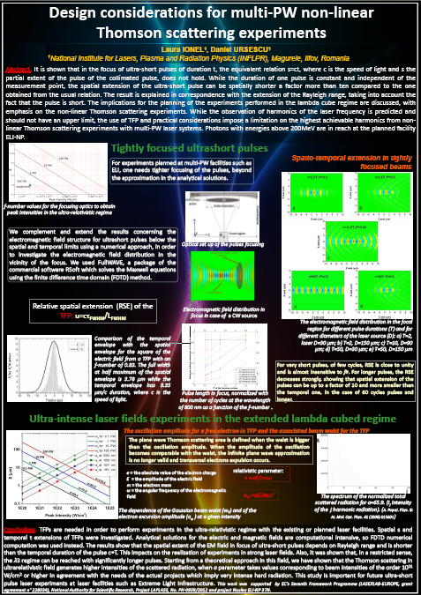

APPENDIX A – Young Scientist Posters – 3rd Place

