www.ICUIL.org

ICUIL Board

Chair
Toshiki Tajima

Co-Chairs
Chris Barty

Alexander Sergeev

Secretary
Terry Kessler

Treasurer
Tsuneyuki Ozaki

Annual Report to IUPAP
September 2013

ICUIL Activity Overview

The International Committee on Ultra-High Intensity Lasers continues to be engaged with the growth and vitality of the whole international field of ultra-high intensity lasers. Our goals are to provide a venue for discussions, among representatives of high-intensity laser facilities and members of user communities, on international collaborative activities such as the development of the next generation of ultra-high intensity lasers, exploration of new areas of fundamental and applied research, and formation of a global research network for access to advanced facilities by users. As summarized in the highlights of this report, ICUIL has been very active in promoting collaborations required to design and build high-intensity laser infrastructures for the advancement of the international physics community.

ICUIL Biennial Conferences

ICUIL has a decade-long history of promoting unity and coherence in the field by convening conferences dedicated to ultra-high intensity lasers and their applications. The 6th biennial ICUIL conference will be held September 16-21 in Goa, India and will be hosted by the Tata Institute of Fundamental Research, with R. Kumar serving as the conference chairman. It will be located in the city of Goa, on the west coast of India, about 600 km south of Bombay. Attendees will be able to visit the Tata Institute of Fundamental Research (TIFR), the Bhabha Atomic Research Centre (BARC) and the Raja Ramanna Centre for Advanced Technology (RRCA). TIFR has an operational 100TW laser system focusing on basic intense laser science and applications while RRCAT has a 150 TW system for laser particle acceleration. BARC will soon have a 200 TW laser system.

2013 Annual General Assembly (GA) Meeting
A twelve member quorum was reached at the annual GA meeting held in Livermore CA, US on July 18th. The agenda for the meeting consisted of member rotation, the 2014 ICUIL Conference, website development, the world map, fund raising, and laser infrastructure initiatives and collaborations such as ELI, XCELS, and IZEST. The role of educational institutions in addressing the high demand for individuals trained in laser science, engineering, and technology was discussed. Bi-monthly teleconferences continue to be effective in maintaining progress in each of these activities.

ICUIL Member Rotation
Several of the current ICUIL members will have completed two terms of service by 2016 and will be required to step down according to the bylaws of the ICUIL charter. A phased member rotation in 2014 is being planned to provide continuity. Member rotation has been carried out, in small steps, to maintain continuity and ensure that ICUIL continues to advance while maintaining balance both geographically and between the various high field science working groups of IUPAP.

ICUIL Newsletter
The fourth ICUIL Newsletter (Volume 4) was sent out to the high intensity laser community on May 2013 and is also available at the ICUIL website. The chief editor, C. Labaune, managed the illustration and publication resources to distribute an eight-page newsletter to hundreds of readers, highlighting the major laser construction and laser science projects within the HIL community, major conferences, and related workshops. ICUIL’s goal is to continue publishing an annual newsletter.

Fund raising
ICUIL has continued its corporate support program to afford maintenance of the ICUIL website, publish an annual newsletter, and support biennial conferences. The remaining funds are being targeted towards support of new outreach activities including student competitions held at the biennial conferences.

ICUIL Website
One of the features of the ICUIL website is an interactive world map that highlights the high intensity laser facilities around the world as shown below. A survey of the worldwide laser community has been conducted by ICUIL in an effort to provide an accurate accounting of all existing and planned ultrahigh intensity laser facilities that are capable of reaching intensities above 10E19 W/cm2. The map (shown below) exists on the ICUIL web site both in downloadable, high quality static form and also as a dynamic interactive map based on an underlying Google-Maps engine that has been licensed by the Lawrence Livermore National Laboratory for this purpose. The data base generated in the creation of the ICUIL world map reveals that ICUIL related activities are growing worldwide at an incredible pace. In 2009 the sum of the peak power from all existing ICUIL related facilities was 12 PW. Survey data suggests that by 2015 this number will be over 100 PW.

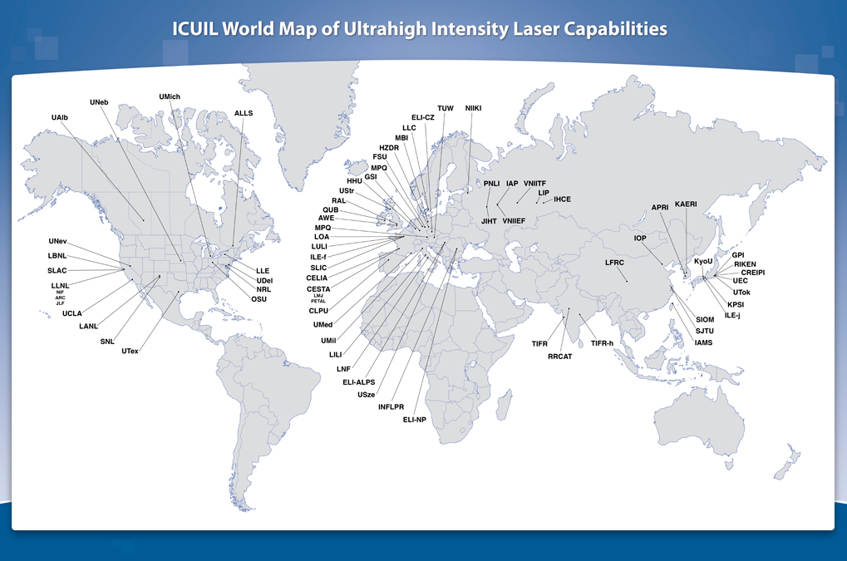

2013 ICUIL Membership

Toshiki Tajima Chairman International
Chris Barty Co-Chairman United States
Alexander Sergeev Co-Chairman Russia
Terry Kessler Secretary United States
Tsuneyuki Ozaki Treasurer Canada
Gerard Mourou France
Hiroshi Azechi Japan
John Collier United Kingdom
Dino Jaroszynski United Kingdom
Thomas Kuehl Germany
Ravi Kumar India
Christine Labaune France
Wim Leemans United States
Ruxin Li China
Chang Hee Nam Korea
Bedrich Rus Czech Republic
Wolfgang Sandner Germany
Heinrich Schwoerer South Africa
Ken-ichi Ueda Japan

Associate Members (without vote)
Ryosuke Kodama Japan
Jong-Min Lee Korea
Sandro de Silvestri Italy
Nilson Dias Vieira Jr. Brazil
Claes-Goran Wahlstrom Sweden

ICUIL Related Science and Technology Highlights
- ICFA/ICUIL Joint Task Force (JTF)
ICUIL and ICFA have exercised their Joint Task Force (JTF) on future applications of laser acceleration to promote and encourage international collaboration between the accelerator and laser communities. The JTF outlined a roadmap for advancing laser technology to meet the challenge of future accelerators that use or rely on very high-average power lasers. Following two workshops, a document describing the recommended future course of actions was published in the ICFA Newsletter. The laser driven acceleration approach is paving a way to help a variety of high-energy accelerator physics issues such as the future high-energy collider, ion beam sources, electron beam source for FEL, and compact ion beam cancer therapy application. Although the scientific case for the laser based accelerator is compelling, the technological requirements are challenging. One of the most urgent needs for development is an efficient high-average power laser technology. In order to meet these recommendations and challenges, a project called International Coherent Amplification Network (ICAN) between the laser and accelerator communities was launched last year. This network has identified the fiber laser as the primary candidate for achieving highly efficient, high-average power lasers in the future. In an 18-month pilot project funded by the EU, 64 fiber lasers were coherently combined to form one laser beam. An article describing the extension of this laser technology for accelerator physics appeared in Science, Volume 341, on August 16, 2013.
The EC has launched a new initiative centered at CERN by forming European Network for Novel Accelerators, encompassing a few dozen accelerator and laser institutions worldwide. At the last IPAC2012 meeting in New Orleans a meeting was held with the ICFA Advanced and Novel Accelerator Panel. CERN representatives have expressed interest in the ICAN initiative and would consider providing space for a test facility. A description of where ICAN is positioned within the context of new accelerator techniques was requested by CERN Director General, Rolf Dieter Heuer.

- Extreme Light Infrastructure (ELI)
Extreme Light Infrastructure (ELI), the world’s first international user facility for laser research, was established as an International Association on April 11, 2013 in Brussels, Belgium. The event was attended by representatives from the European Commission and various ELI partner countries. ELI is part of the European Strategy Forum on Research Infrastructures (ESFRI) roadmap for international research infrastructures of high priority for Europe. Based on strong international collaborations it is being constructed in three countries utilizing EC Structural Funds. In the Czech Republic, ELI-Beamlines facility will provide a variety of petawatt scale laser capabilities that will enable creation of secondary, laser-driven particle and light sources for basic science and industrial applications. In the Romanian ELI-Nuclear Physics facility, two 10 PW lasers are planned to be constructed in conjunction with a world-leading gamma-ray source to investigate a wide range of nuclear science. In Hungary, the ELI-ALPS facility will concentrate on the development and applications of intense sources of attosecond laser pulses. With its ultra-intense and ultra-short pulses of light it will create new states of matter in dense plasmas, probe the structure of vacuum and produce secondary radiation of high-energy photons or particles.
A new legal entity, the ELI-DC Association, was created in order to manage and support the implementation of the existing and future ELI research centers and to preserve the pan-European dimension of the overall project. It will also organize the establishment of an international consortium that will be in charge of the future operation of ELI, preferably in the form of a European Research Infrastructure Consortium (ERIC). ICUIL member Wolfgang Sandner is its designated Director General.

- Exawatt Center for Extreme Light Studies (XCELS)
XCELS is one of the six mega-science projects that were chosen by the RF Government on a competitive basis in 2011. This initiative is analogous to ESFRI in that it requires participation in constructing and exploiting research complexes of foreign partners. A scientific Workshop, “The Laser Ascent to Subatomic Physics and Applications” took place at the French Embassy in Moscow on April 26. Memoranda of collaboration in the area of extreme light between CEA, Ecole Polytechnique and IAP, and between CEA, Ecole Polytechnique and Russian National Nuclear University (MEPHI) were signed during this workshop. It was organized by the Embassy of France in Russia together with the IZEST and the Institute of Applied Physics of the Russian Academy of Sciences. About 70 scientists, from Russia, France, other European countries, China and Taiwan participated in the event and agreed to promote creation of XCELS, IZEST, collaboration between French and Russian research laboratories in the area of extreme light science, application, and technologies and partnership of appropriate laboratories to form consortia capable of performing complementary research.
Construction of the fourth ELI center containing the world’s most powerful subexawatt laser complex is currently pending and represents a common goal with the XCELS project. This cooperation opens up a unique opportunity for EC countries to implement the full ELI project and for Russia to become an equitable partner of the European scientific community. A legal form of Russian participation in the ELI+XCELS alliance may involve an associated membership in the ERIC. On June 19, the second evaluation meeting took place at the EC headquarters in Brussels, where the EC appointed experts, Susana Gota Goldman (CEA) and Wolfgang Sandner (ELI), fully supported the ELI+XCELS alliance.

- International Center for Zetta-Exawatt Science and Technology (IZEST)
IZEST, headquartered at the Ecole Polytechnique, will unify a number of exawatt class facilities such as the ELI-Fourth Pillar, the Russian XCELS, as well as possible Japanese and Chinese exawatt lasers. The initial experimental program will be performed by using the most powerful European laser PETAL at the CEA-CESTA in Bordeaux and the Russian Exawatt once completed, but most of the preparatory activities will be carried out in the IZEST-associated laboratories around the world. Almost 30 laboratories in 13 countries have signed a collaboration agreement with IZEST. The second IZEST meeting was held November, 2012 at Strathclyde University, Scotland. The meeting included a presentation from Peter Higgs as a distinguished speaker, and many other prominent speakers. The main objective of the conference was to explore the potential of very high fields available from the next generation of high power lasers and also the potential of combing them with high energy particle beams from laser-plasma accelerators, for fundamental studies of the structure of matter. The third IZEST meeting was held at the Lawrence-Livermore National Laboratory in July, 2013 to discuss the development of novel exawatt and zettawatt laser technologies and the development of frontier, ultrahigh intensity science and applications. The main mission of the International IZEST center is to position the scientific community behind this proposal to use the laser field to probe the nonlinearity of vacuum.

- Shanghai Institute of Optics and Fine Mechanics (SIOM)
In China, Ruxin Li from the State Key Laboratory of High Field Laser Physics, is pursuing the challenge of producing laser intensities in the ultra-relativistic regime, where laser pulses with peak power of 10 PW level and beyond are necessary. Laser amplification in Ti: sapphire has led to generation of 1.5PW laser pulses. With successful control over the parasitic lasing, his group obtained a record energy of 72.6 J from a Ti: sapphire of 100mm size, corresponding to a record power of 2PW after the amplified chirped pulse is compressed to 26 fs. This represents an important step forward in the development of ultra-high intensity laser sources based on the scheme of CPA. For the realization of 10PW and beyond, the optical parametric chirped pulse amplification (OPCPA) scheme is a promising alternative approach. In contrast to CPA where the laser energy is gained due to the laser action based on population inversion in laser materials, OPCPA is based on the parametric amplification in nonlinear optical crystals. They demonstrated the highest energy broadband OPCPA at 800nm by using a 80-mm in diameter LiB₃O₅ (LBO) crystal, with an output energy 28.68 J, a bandwidth of 80 nm (FWHM) and a conversion efficiency of 25.8%. After pulse compression, the peak power of 0.61 PW was produced.

- Center for Relativistic Laser Science (CoReLS)
In Korea, the Institute for Basic Science (IBS) opened the Center for Relativistic Laser Science. The Korean national nine-year program, Ultrashort Quantum Beam Facility (UQBF) Construction Program, was successfully completed in 2012 and has started an international users' service. The Korean government is now forming a national plan for applied research projects using this facility. When fully installed, IBS will comprise 50 research centers, each of which focuses on a selected research topic in basic science. One of the earliest research centers is the Center for Relativistic Laser Science (CoReLS), which explores the superintense laser-matter interaction. CoReLS’s research is focused on the understanding of physics under extreme conditions induced by superintense laser fields. The goal is pursued cooperatively by the five research groups of CoReLS: laser group, low-density laser-plasma group, high-density laser-plasma group, atto science group, and laser-plasma theory group. CoReLS is directed by Prof. Chang Hee Nam who has pioneered the development of advanced femtosecond laser technology and atto science in Korea. Two petawatt beamlines: 1.0 PW and 1.5 PW at 30 fs, the latter being the most powerful femtosecond laser as of 2012, were developed by the UQBF project and led by Prof. Jongmin Lee. Enthusiastic researchers are joining from around the world.

